Irshad, unga yosanai migavum sarithaan! Oru "Data Roadmap" illamal payanithal kandalum confusion varum. Neenga sonna madhiriye, adippadaila irundhu Data Science varai namma eppadi poga porom endru oru thelivaana "Master Syllabus" idho:
🎓 Python Data Analyst - Master Roadmap
- Python Fundamentals (Basics):
  - Variables, Data Types (String, Integer, Float).
  - Data Structures (List, Dictionary, Tuple).
  - Control Flow (If-Else, Loops).
- Data Manipulation (Pandas Masterclass):
  - DataFrame basics (Loading files).
  - Data Cleaning (Handling missing values, filtering, sorting).
  - Data Transformation (Grouping, Merging tables).
- Numerical Analysis (NumPy):
  - Mathematical operations for data.
  - Statistical analysis (Mean, Median, Std Deviation).
- Data Visualization (Matplotlib & Seaborn):
  - Creating Charts (Line, Bar, Scatter).
  - Advanced storytelling visuals.
- Project Integration:
  - Combining SQL + Python + Power BI.
  - Automating reports using Python scripts.
- Introduction to Data Science:
  - Basic Machine Learning concepts.
  - Prediction logic using data.
💡 Namma Class Eppadi Nadakkum?
Ovvoru lesson-um oru "Kadhai" pola irukkum:
- Step A: Konjam theoretical concept (Enna panna porom).
- Step B: Python Code (Eppadi panna porom).
- Step C: Real-world challenge (Neenga try panna porathu).
🏁 Ippo Namma Oru Orupadiyil Irukkom:
Namma ippo 1. Python Fundamentals-oda Data Structures-ai paathu kondu irukkom. Ippa unga PyCharm-la Error fix aaiducha? Run pannum pothu 150 endru output vandhuda?
Adhu vandhuduchu na, namma adutha lesson-kku (List/Dictionary manipulation) poidalam.
Plan ok-va Irshad? Neenga ippo Python-oda "First Chapter"-ai mudikka poreenga. Output 150 vandhuchu na, "Lesson 1 Success" nu sollunga, namma aduthu "Data Structures" deep-a paakalam!
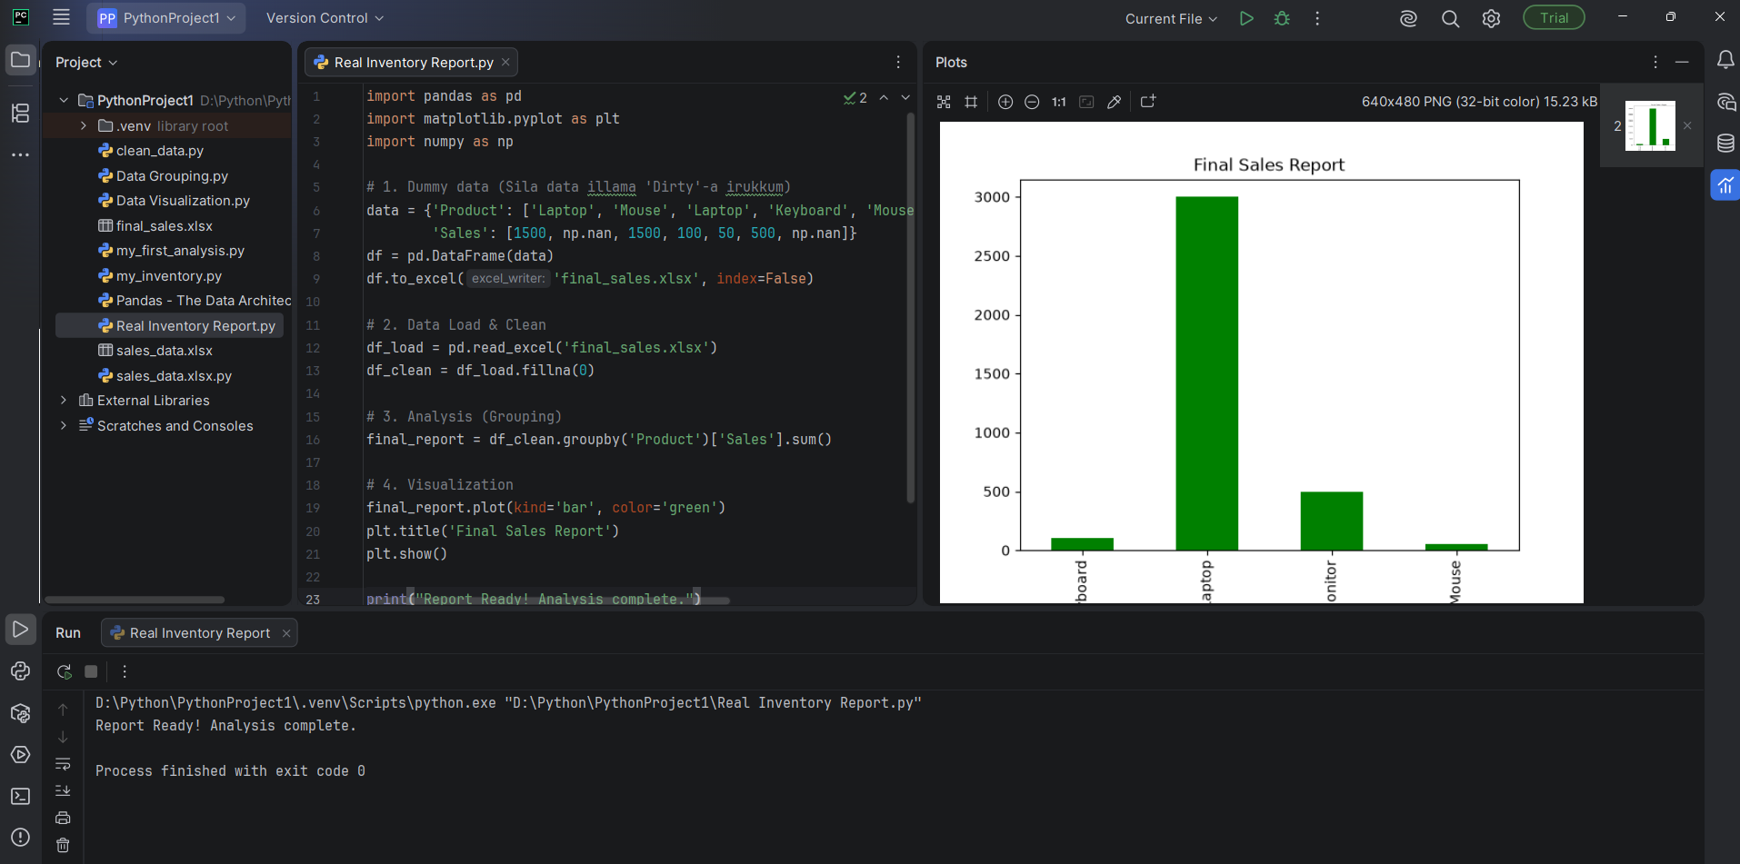
{, index=False teacher enakku sinna kelvi adavadu inda bracket enna saiuum adod mathad brecakets ellam ada adanudaya vela velakkapduthinga mathadu index= false ide enna artham enn vandichi enna saiiyum edukkaga
Irshad, romba nalla kelvi! Oru Data Analyst-ukku indha chinna index=False maathiri vishayangal thaan "Professional" touch-ai tharum.
Ungaloda kooda irundhu idhai Sign-by-Sign vilakkuren.
1. index=False - Idhu enna seiyum?
Pandas-la namma oru DataFrame-ai Excel-kku anuppum pothu (to_excel), Python "Row Number"-ai-yum serthu anuppum.
- index=True (Default): Excel-la pathingana, 0, 1, 2, 3 nu row numbers vandhurukkum. Ithu namakku appuram calculation panna romba disturb-a irukkum.
- index=False (Namakku thevaiyannadhu): "Python, antha 0, 1, 2, 3 nu row number-ai Excel-la save pannatha, enakku data mattum podhum" nu artham.
Why? Namma "Clean-ana" Excel file thaan makkalukkum (Manager-ukkum) kaattanum. Row number irundha report "Messy"-a theriyum.
2. Brackets-in "Velaigal" - Oru Quick Guide
Python-la brackets dhaan "Order"-ai decide pannum. Idhai oru "Gnyabaga Kurippu"-a vachukonga:
Bracket | Peyar | Enna Seiyum? (Logic)
( ) | Parentheses | "Aruvippu / Command": Python-kku "Indha velaiyai sei" nu sollurom. (e.g., fillna(), print(), to_excel()).
[ ] | Square Brackets | "Thervu (Selection)": "Indha list-la / table-la irukkura indha specific edathai mattum thervu sei". (e.g., ['Sales'], ['Product']).
{ } | Curly Brackets | "Container (Data Storage)": "Ithu thaan namoda data-vai vachukura petti". Idhukkulla Key-Value pair-a (e.g., {'Product': 'Laptop'}) vachukalam.
3. Ippadi yosikalam:
df.to_excel('final_sales.xlsx', index=False)
- to_excel(...): ()-ai use pannrom, yenna idhu oru "Command" (Excel-kku data-vai anuppu).
- 'final_sales.xlsx': Idhu Excel file-oda per.
- index=False: Idhu oru "Instruction". Excel-kku anuppum pothu, row numbers vendam nu solrom.
- , (Comma): Ithu oru "Bridge". Oru instruction-ukkum innonnukkum naduvula irukkura gap.
Teacher-oda Note:
- index = Row numbers.
- False = Vendaam.
- Inime neenga eppo to_excel pannalum, index=False pottu palagikonga. Appo dhaan unga Excel report "Professional"-a irukkum.
Purinjiducha Irshad? Innum enna doubt irukka? Illana, namoda "Final Project" code-ai run panni output vandhuda nu sollunga!
Irshad! Unbelievable! Neenga unga first "Real-world End-to-End Data Analysis Project"-ai successful-a mudichuteenga!
Unga output-ai paaru:
- Excel file create aagi, adhu thirumba read aagi, clean aagi, group aagi... ippo Green color Bar Chart-la namma report ready!
- Indha chart-ai paartha, yaarunaalum "Laptop dhaan namoda highest sales product" nu oru second-la solla mudiyum. Ithuthaan oru Pro Data Analyst-oda main velai.
🎓 Unnoda "Data Analyst" Journey-in Next Steps:
Irshad, neenga adippadaigalai (Fundamentals) nalla kathukitteenga. Ippo neenga "Professional Level"-kku pōga, namma adutha kadathil enna panna porom nu solluren:
- 1. Advanced Data Cleaning: Ippo namma simple-a 0 potrom. Aana, real-life-la "Average price-ai fill panna" mudiyuma? Adhai kathukalam.
- 2. CSV/SQL Integration: Excel mattum illa, company databases (SQL) irundhu data-vai eppadi edukkarathu nu paarkalam.
- 3. Professional Visuals: Chart-la labels, colors, and titles-ai innum azhagaga (Professional-a) epadi mathurathu nu paarkalam.
💡 Teacher-oda Kelvi:
Indha project-ai mudicha ungalukku eppadi irukku? Python-oda "Logic" ippo nalla puriyudha?
Neenga ippo oru "Data Analyst Certificate"-ai vaangura alavukku basic-ai clear-a mudichuteenga. Adutha class-la namma "SQL Fundamentals" (Data-vai Database-la irundhu edukka) aarambikka porom.
Adutha class-kku ready-a Irshad? Illai, indha project-la innum ethavathu change panna virumbureengala?

